Pabson Shivraj
Class: 6 Annual Examination - 2081 F.M. 50
Time: 2hrs Subject: Science Set : B
- Choose the correct options . 10
a.What is the unit of force?
i.Newton ii. Kilogram iii. Joule iv.Pascal
b.What of the following is a storing device ?
i.Card reader ii. RAM iii. Monitor iv. Keyboard
c. Which of the following is a biotic component?
i. Air ii. Water iii. Soil iv. Bacteria
d. Which gland secrets bile ?
i. Salivary gland ii. Liver iii.Gastric gland iv. Pancrease
e. The sum of kinetic and potential energy is known as …….
i. Chemical energy ii. Mechanical energy
iii.Heat energy iv.Magnetic energy
f. Which one is the SI unit of energy ?
i. Joule ii.Calorie iii. Watt iv. Newton
g. Which of the following chemical is known as table salt?
i. Sodium chloride ii. Sugar iii. Detergent iv. Baking Powder
h. Which of the following is a liquid metal?
i. Iron ii.Copper iii. Silver iv. Mercury
i. Which type of soil is the best for cultivation ?
i. Loam ii. Clay iii. Sand iv. both clay & sand
j. What is the temperature of inner core of the earth?
i. 4000$°c$ ii. 5000$°C$ iii. 6000$°C$ iv. 7000$°$ C
Group B
2.Answer the following questions . 8
a. Define photosynthesis.
b. In which circuit does a lamp glow?
c. Define vertebrates.
d. Give any two examples of a biotic components.
e. What is simple machine?
f. What is energy?
g. Name any two chemical substances which are used in daily life.
h. Name any two coinage metals..
Group C
3.Short answer type questions . 16
a. What is heat? Write its SI unit.
b. What are the effects of force on a body?
c. Write the application of energy in our daily life.
d. Differentiate between homogeneous & heterogeneous mixture.
e. Differentiate between crust & mantle.
f. Write any two properties of metals.
g. Define saponification . Name the chemical substances used to make
soap.
h. Name the three basic types of soil.
Group D
4.Long answer type questions . 16
a. List any four things that we have to remember while using computer & smartphone..
b. Define adaptation .Write any three adaptive features of fish .
c. Differentiate between kinetic energy & potential energy . The mass of vehicle is 2500kg& its velocity is 20m/s . Calculate its kinetic energy.
d. Study the given diagram & anser the following questions..

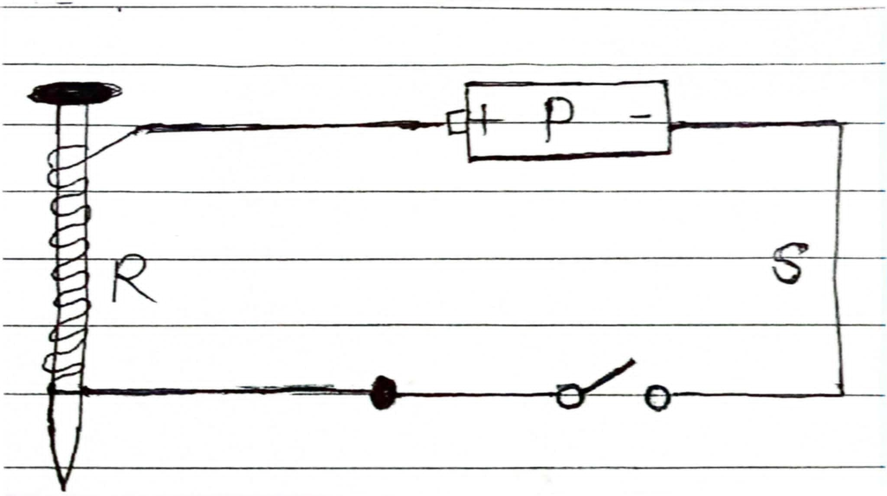

i. What is shown in the diagram?
ii. Name S and P ?
iii. What type of circuit is shown in the diagram?
iv. What will happen if the number of P will increase?
Best of luck

